INDEX
Sr.No | Name of Practical
1 | Create instance of Watson assistant service for implementing artificial intelligence functionalities using IBM cloud regarding Restaurant scenario.

Definition: Create instance of Watson assistant service for implementing artificial intelligence functionalities using IBM cloud regarding Restaurant scenario.
Aim: Use Watson Assistance make a chatbot.
Outcomes/Learning: In this practical we learn that how we make chatbot and how to train them.
Working/Perform: In this we have to make a chatbot by use of IBM Cloud using Watson assistant services..
Required Tool:- IBM Cloud.

STEP 1: Go to resource list and click on create resource.
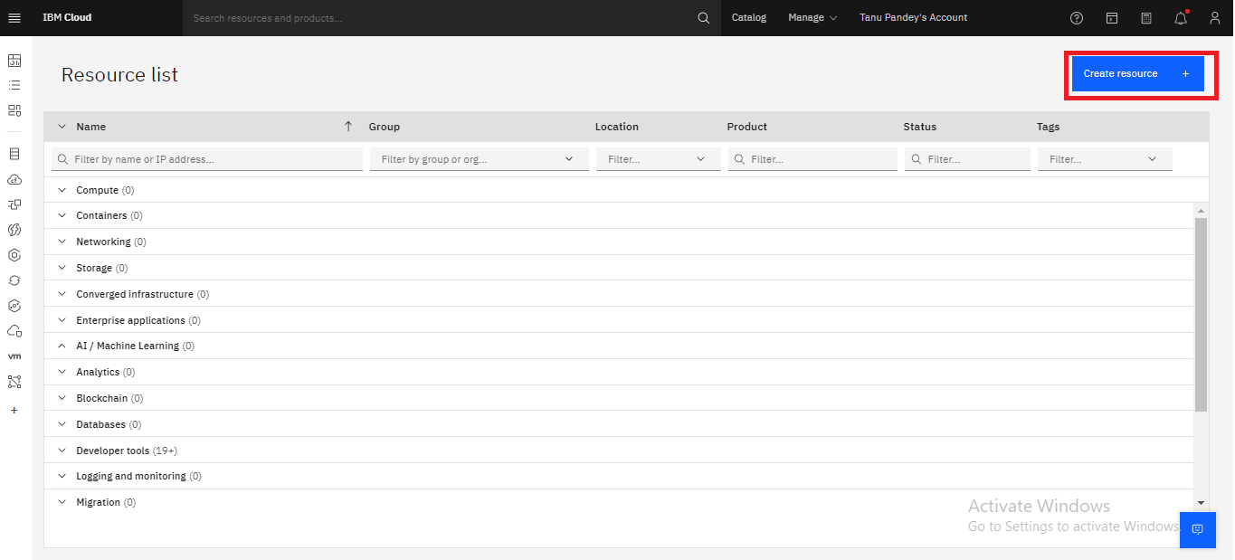

STEP 2: Now search in Watson assistant in Catalog.
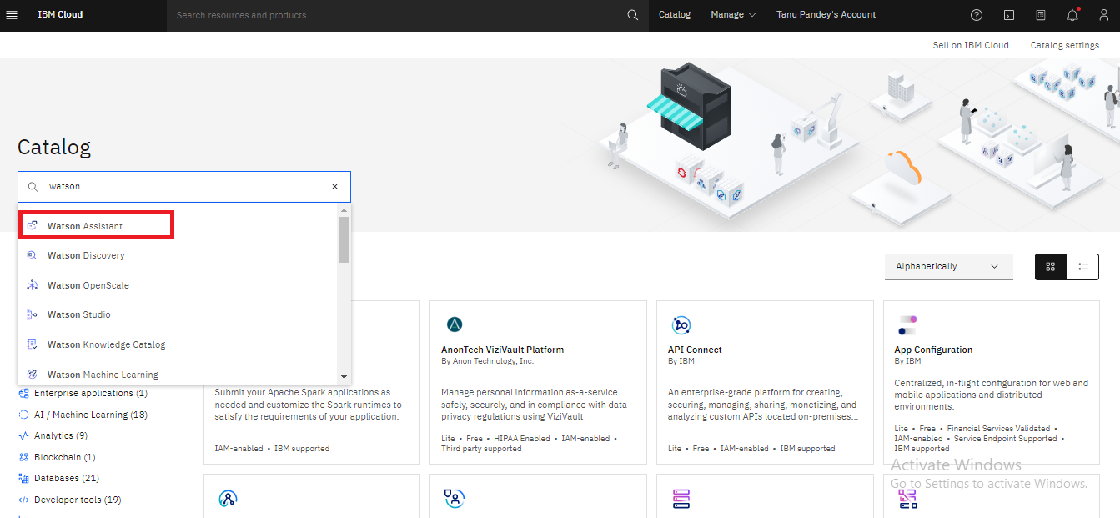
STEP 3: Now select the region in which your Watson assistant services /chatbot is stored, and tick the checkbox and click on create.
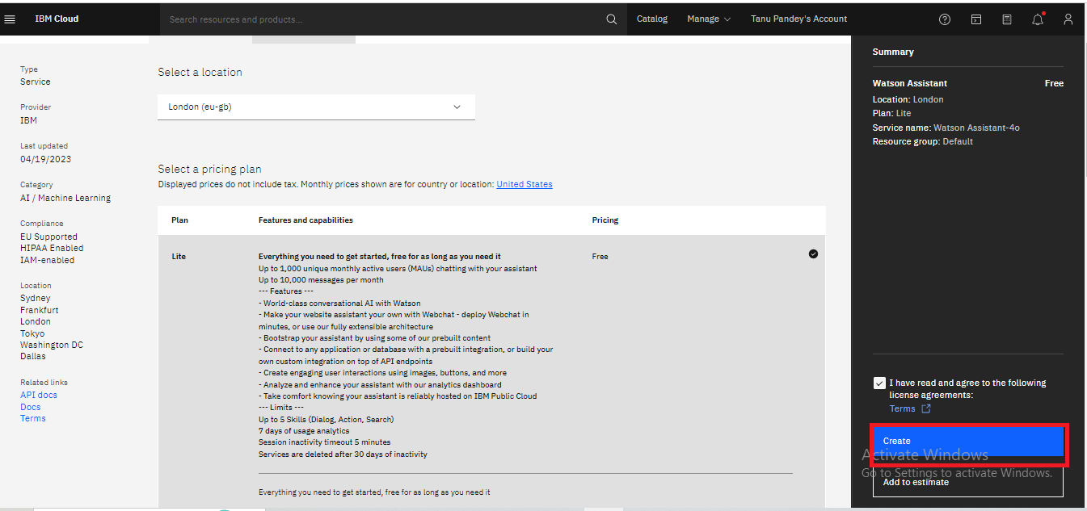

STEP 4: Now click on the launch Watson Assistance button to launch and create our chatbot.
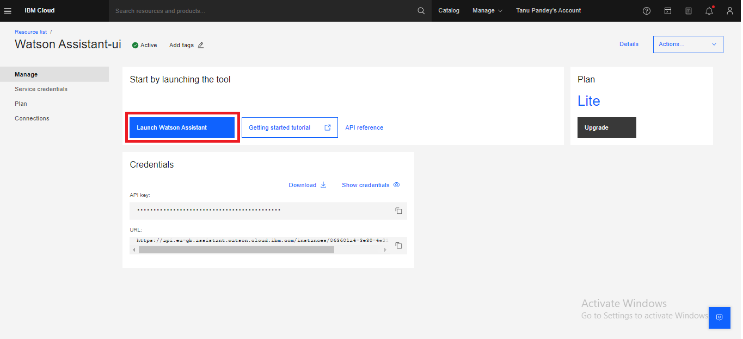

STEP 5: Now give the name of your assistant And write it’s description. And click on Next Button.

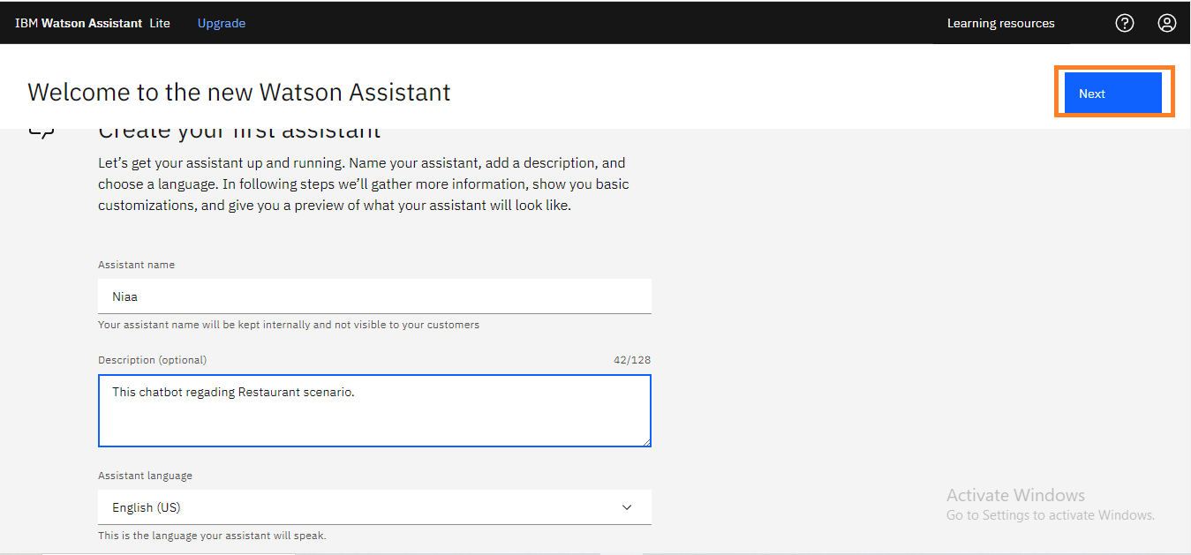

STEP 6: Now in personalize section, in which you want to deploy your chatbot/assistant option select web because we have to deploy it on internet. Then select industry where we work so select software or any field in which you want , then select your role in team building the assistant as developer. Now select the statement which describes your purpose to make an chatbot/assistant. And click on next button.

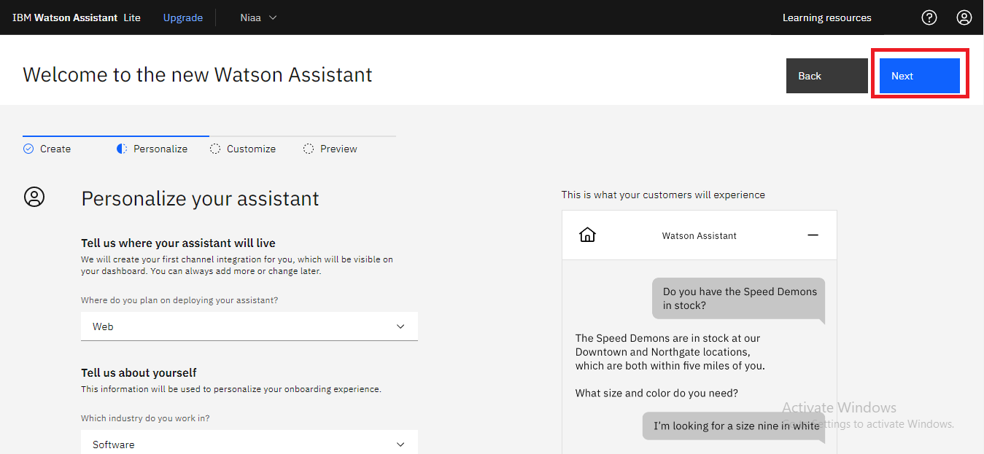

STEP 7: In customize section we can customize our assistant like uploading image for assistant, selecting it’s primary colour basically we can customize it’s chat UI.
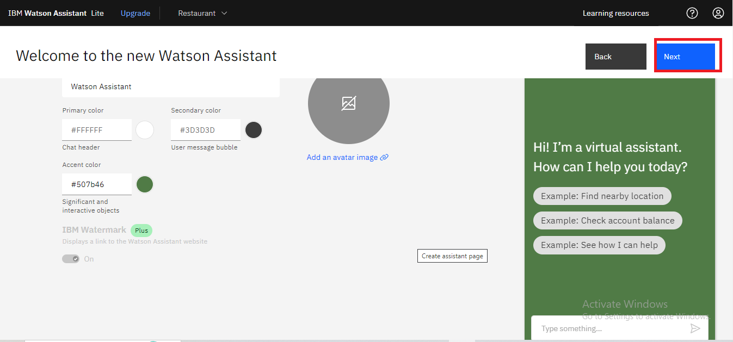

STEP 8: Now in preview section we can see how our chatbot look like in our website and click on create.

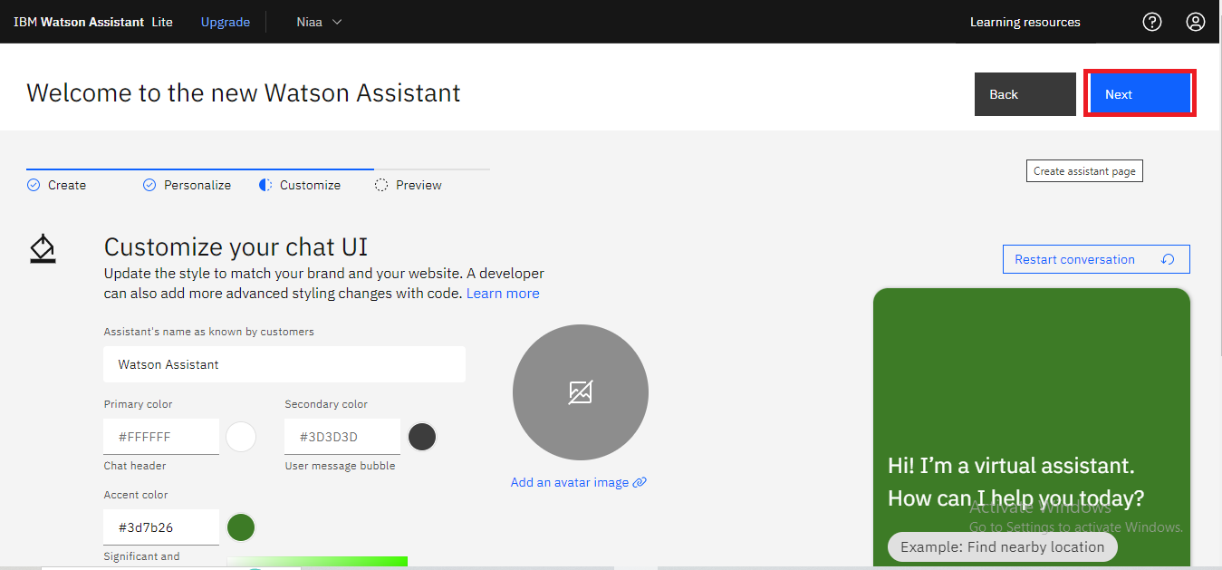

STEP 9: Now in preview section we can see how our chatbot look like in our website and click on create.
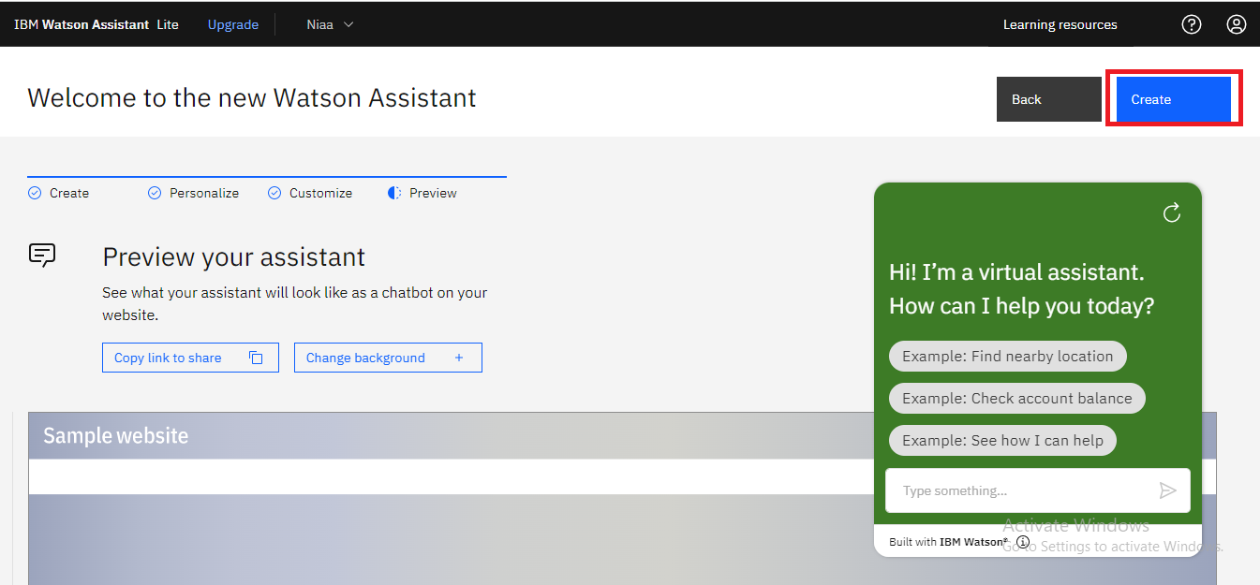

STEP 10: Now our chatbot is created.
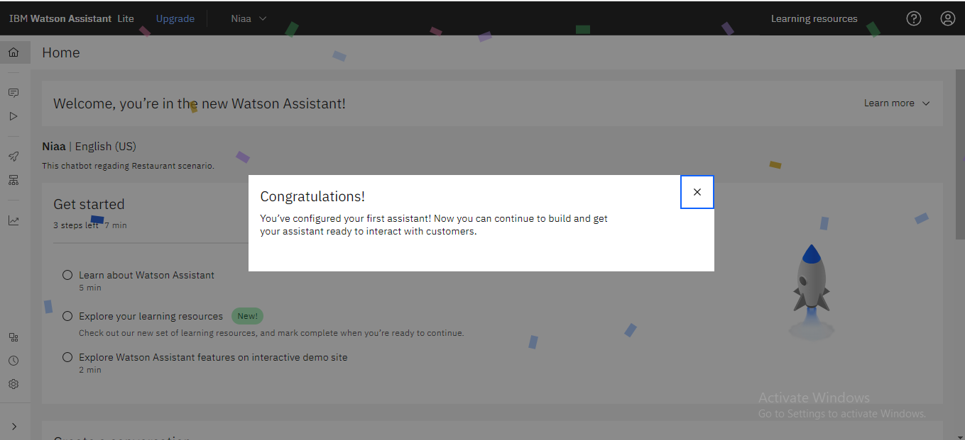

TRAIN OUR ASSISTANT FOR CONVERSATION

STEP 11: To train our assistant first we have to activate Dialog for that go to the assistant settings and click on activate Dialog.
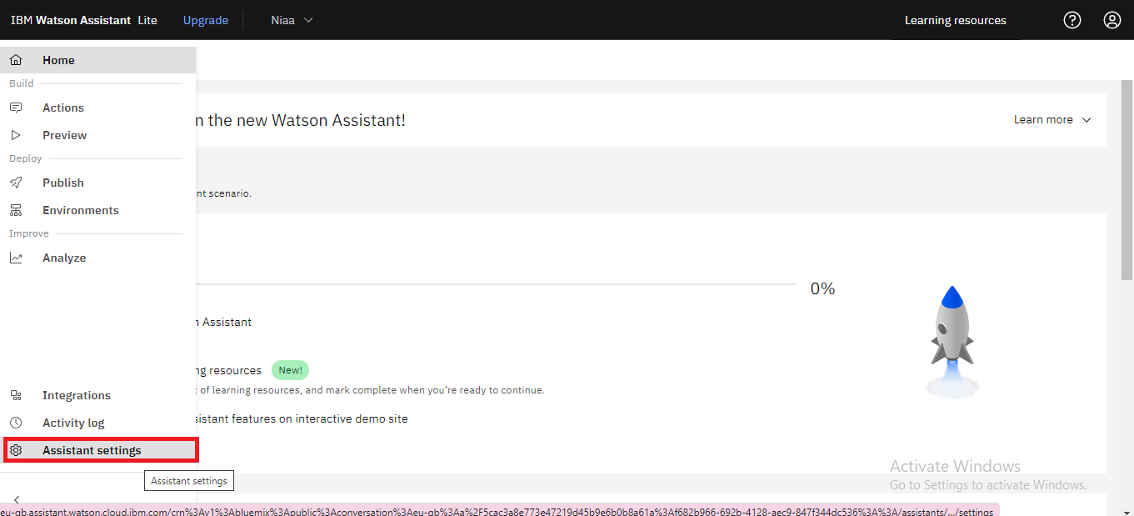

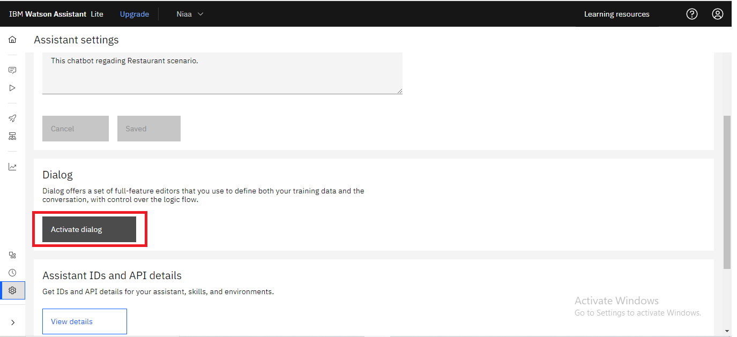

STEP 12: After activating dialog, Go to the dialog section then go to the Intent section and click on create Intent.
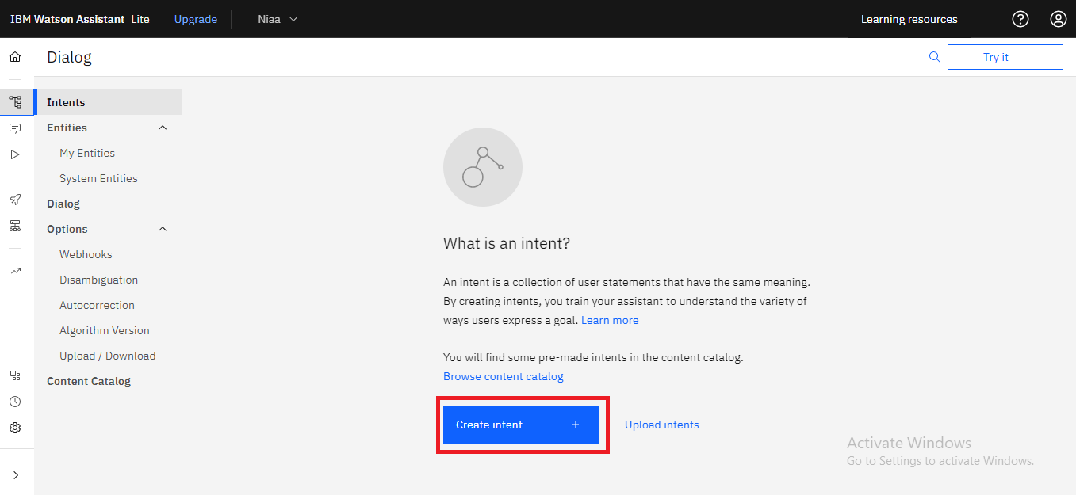

STEP 13: Now create an intent for opening the chat and add the example which user ask the questions.

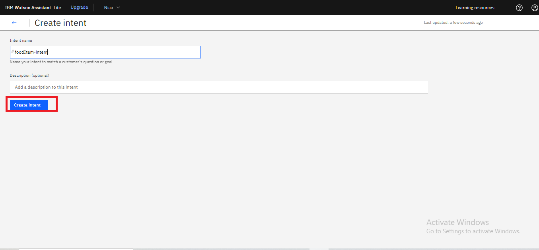

STEP 14: Now create a dialog box then click on create dialog
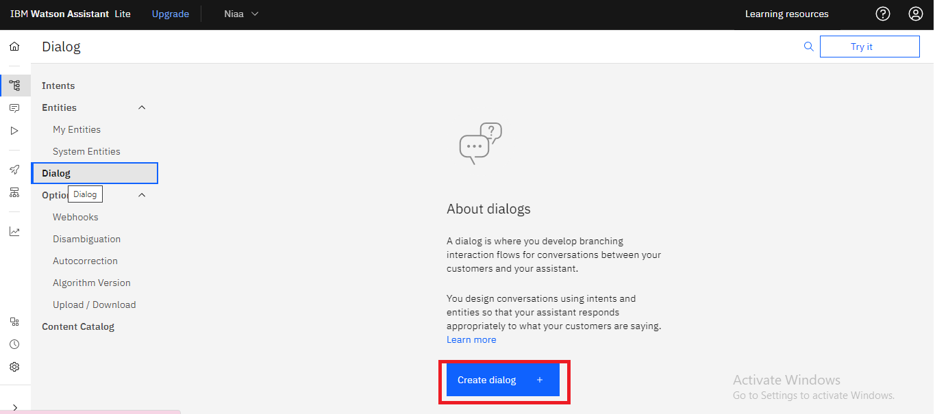

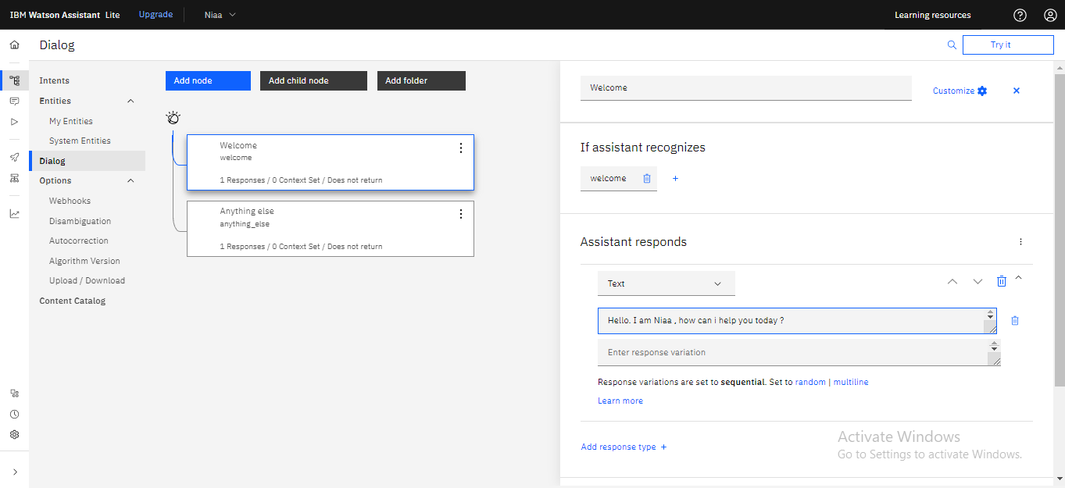
STEP 15: Now create a node below the welcome node.
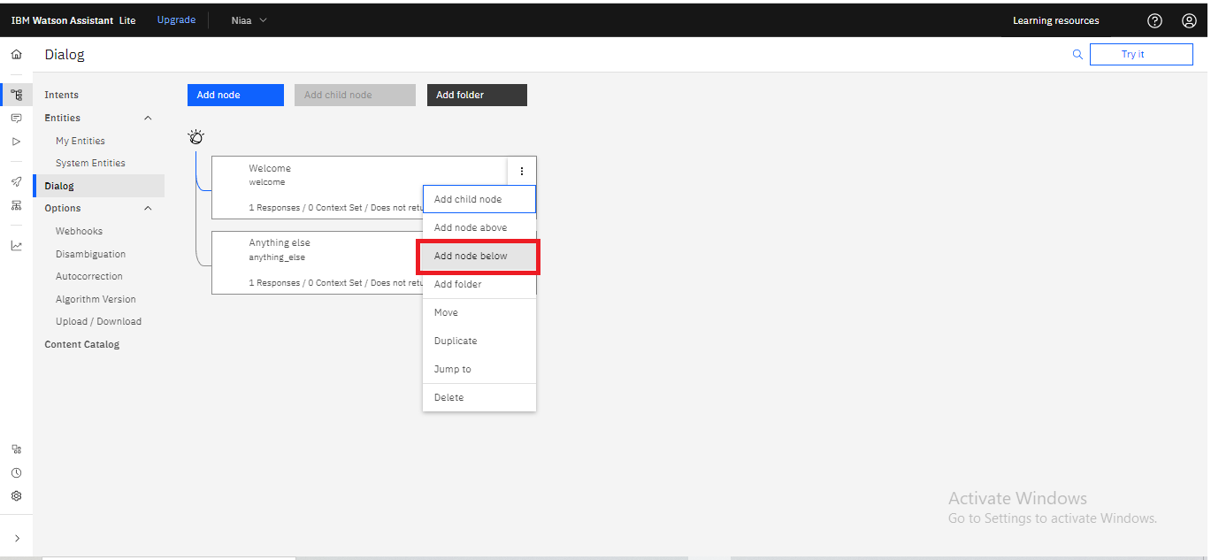
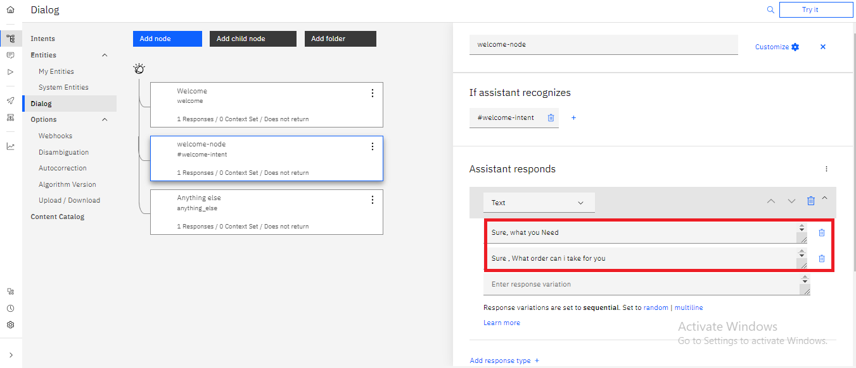

STEP 16:Now we have to create an entity for that click on create entity.

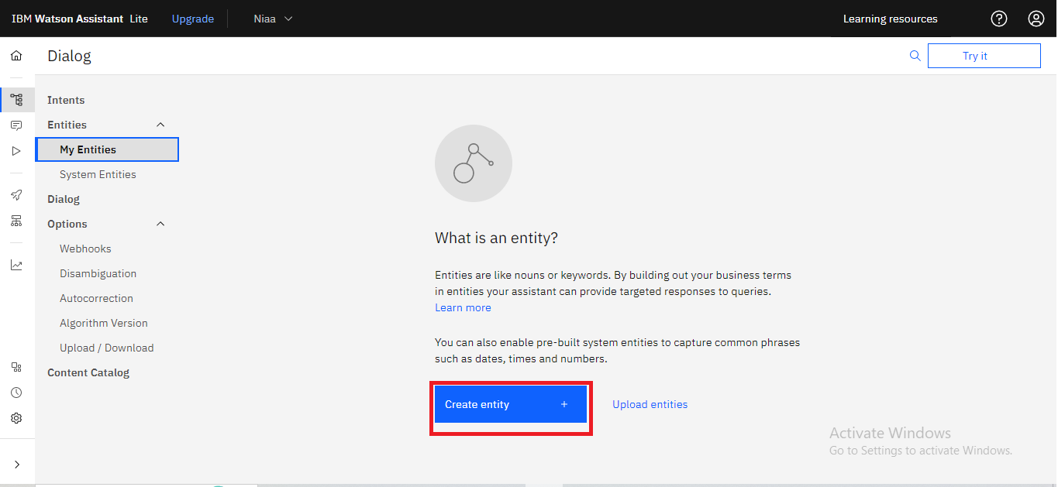

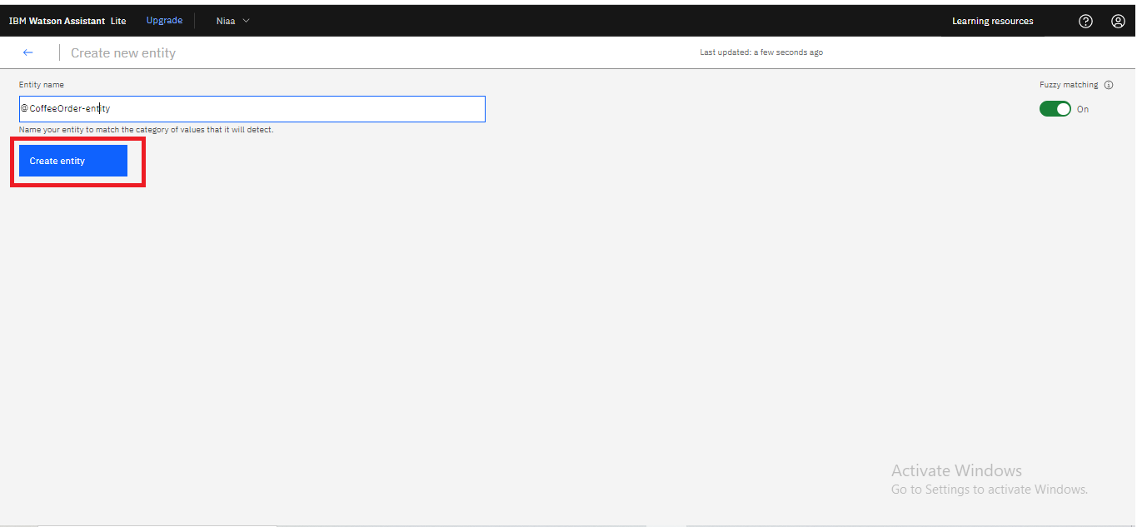

STEP 17:Now add a child node and train it for enat

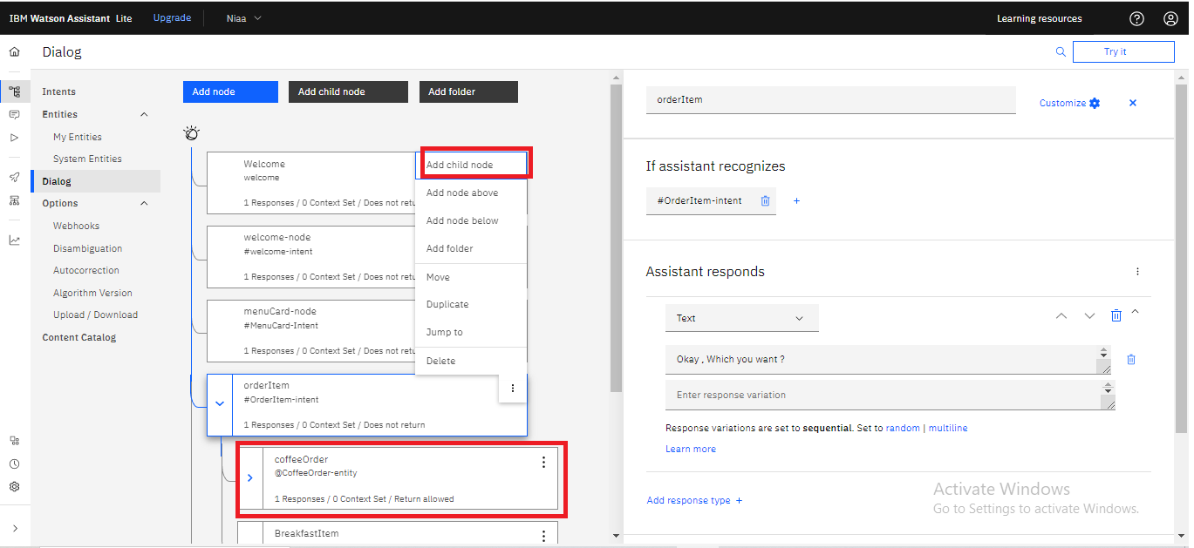

STEP 18:After training our chatbot/assistant is ready.

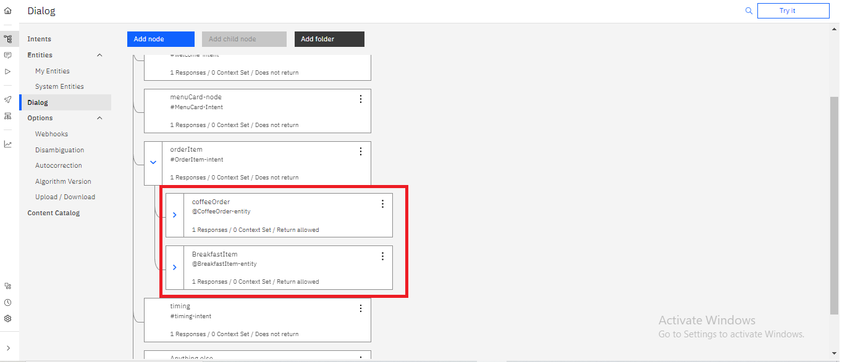

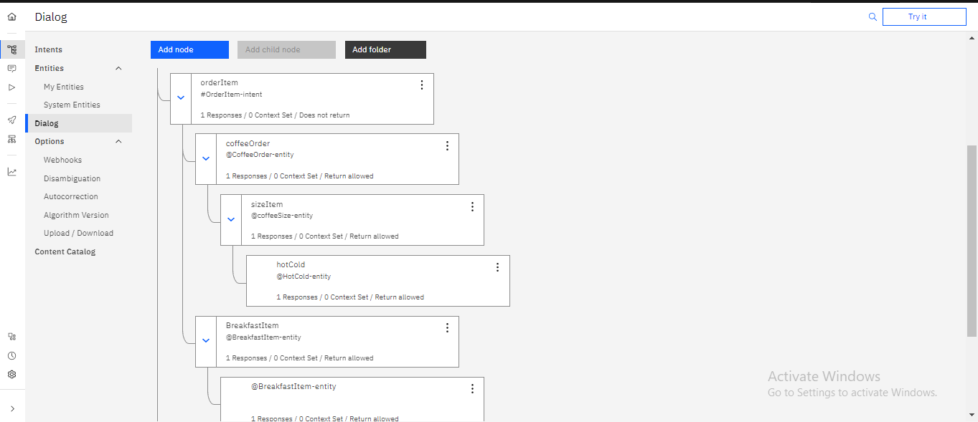

Final result
